Objective:

* Methods

**There are 3 projects and 2 challenge exercises, each worth 20%.**

**Project #1**

Calculating using methods.

**#1 print screen the output below with code below here**

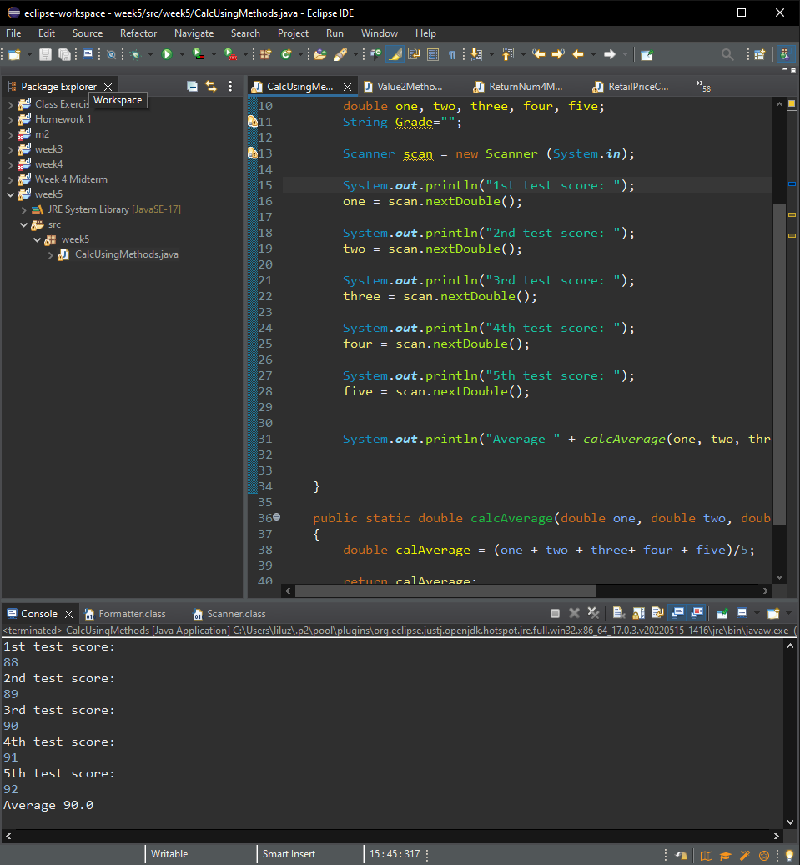

**Project #2**

**#2 print screen the output below with code below here**

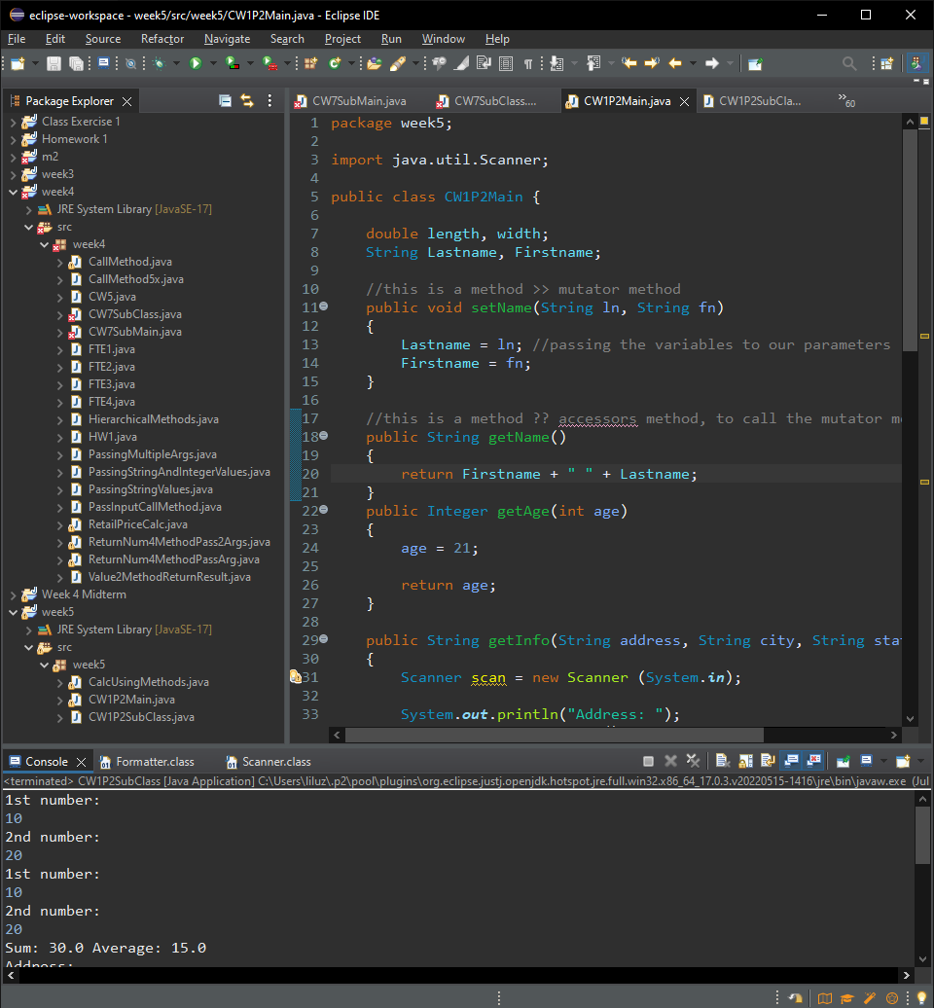

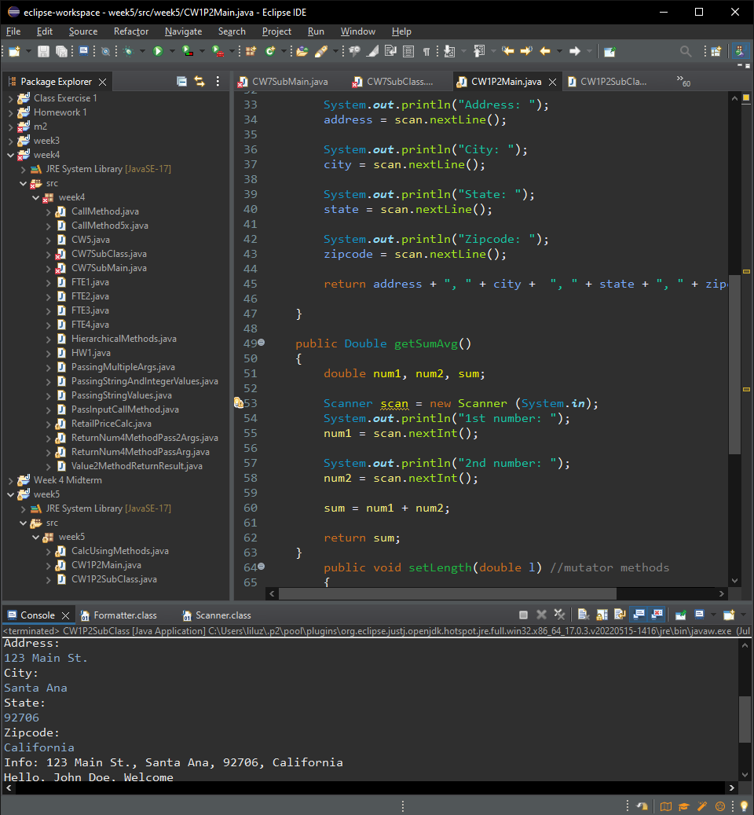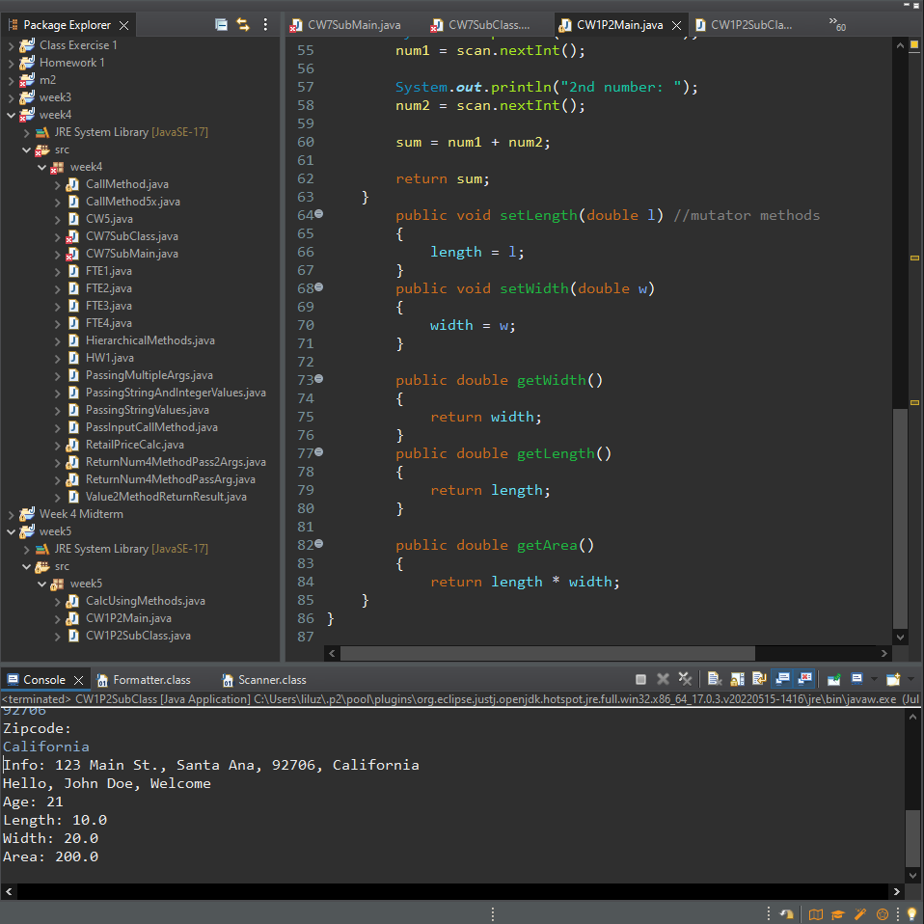

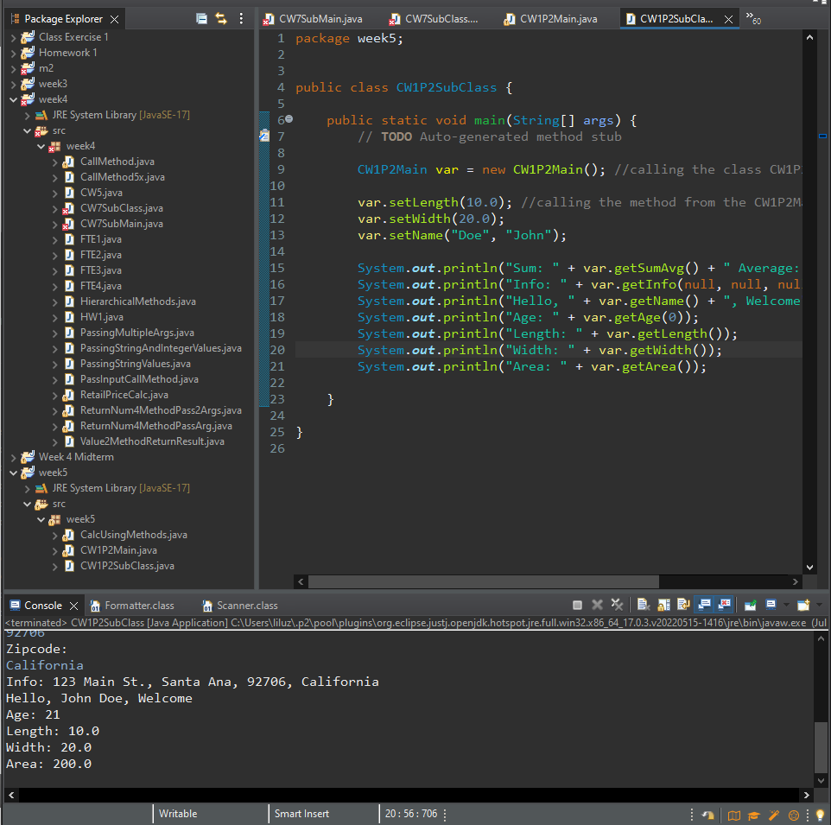 **Project #3**

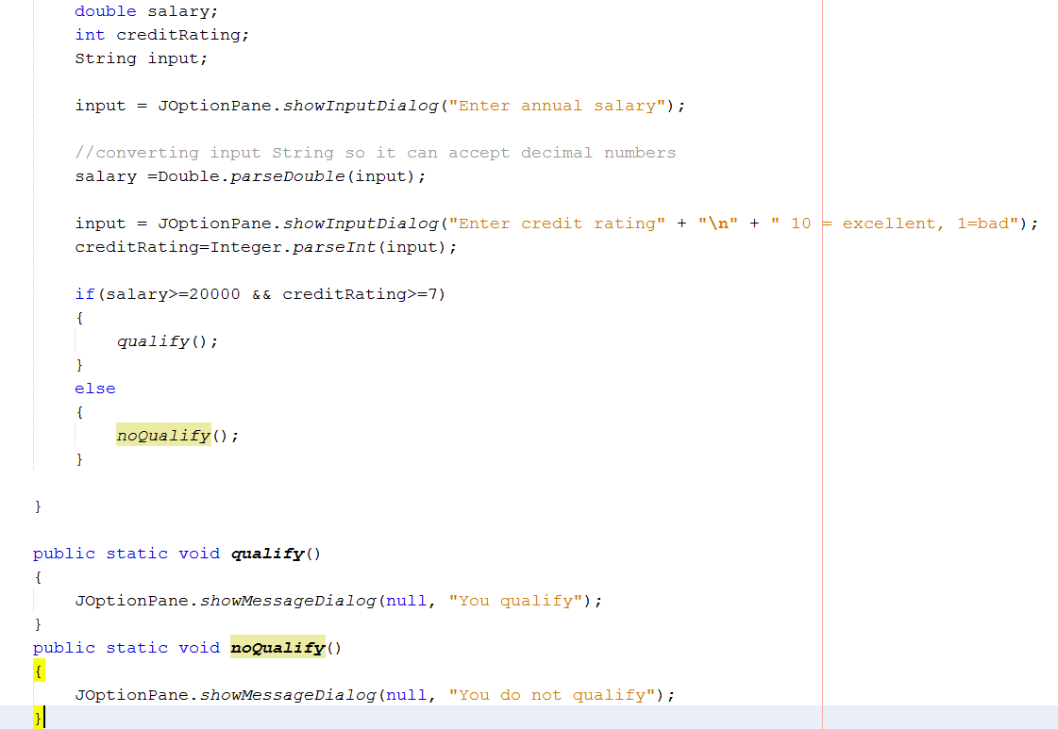

**#3 print screen the output below with code below here**

**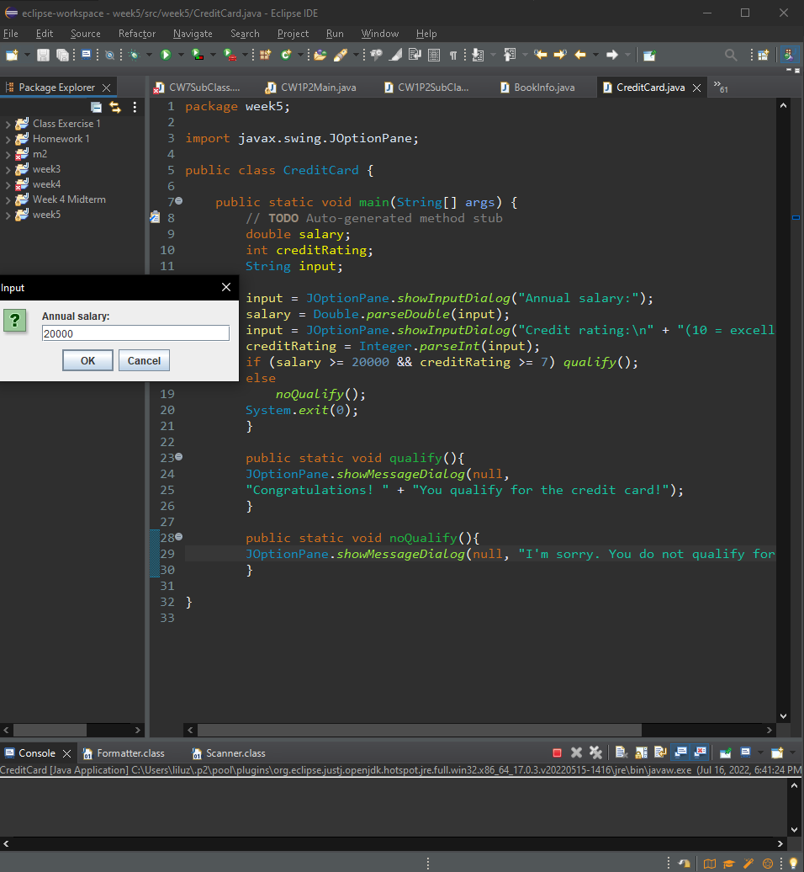  
  
  
  
  
  
  
  
  
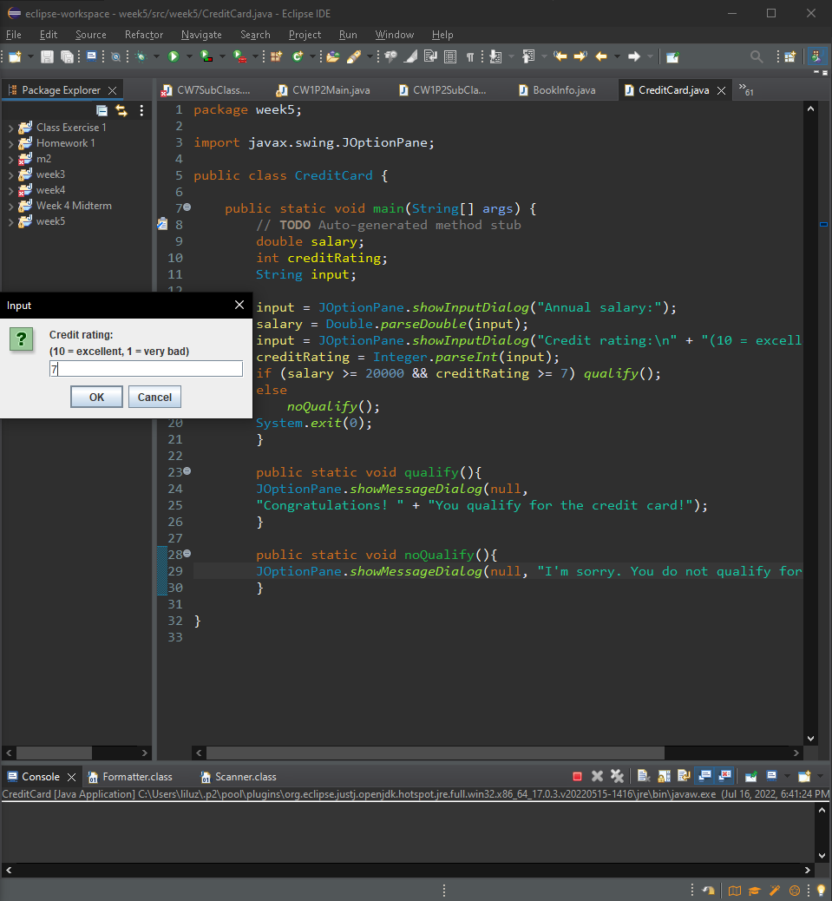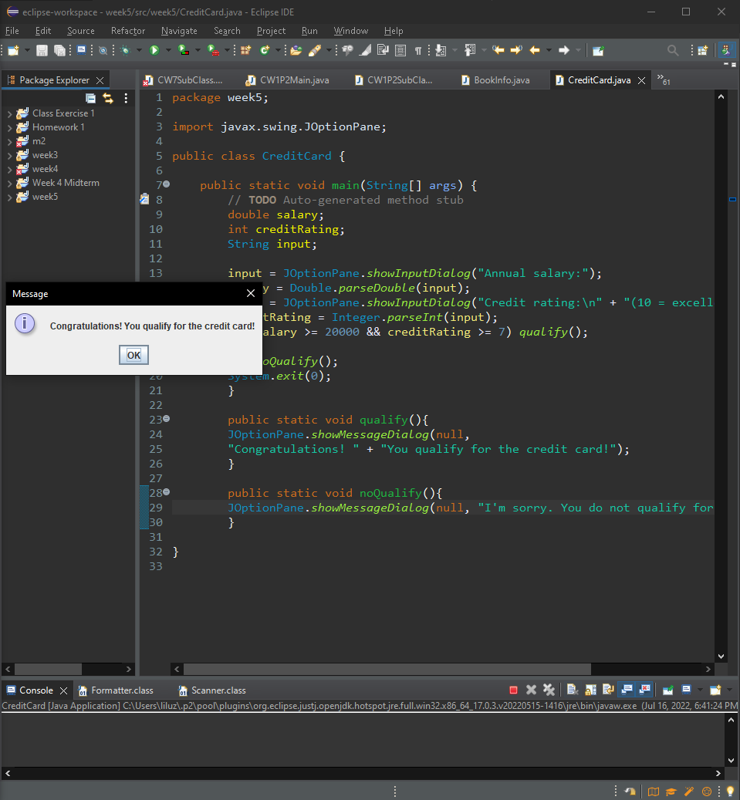**

**Challenge Exercise:** Complete the following below, make sure to have an output.

**#4 print screen the output below with code below here**

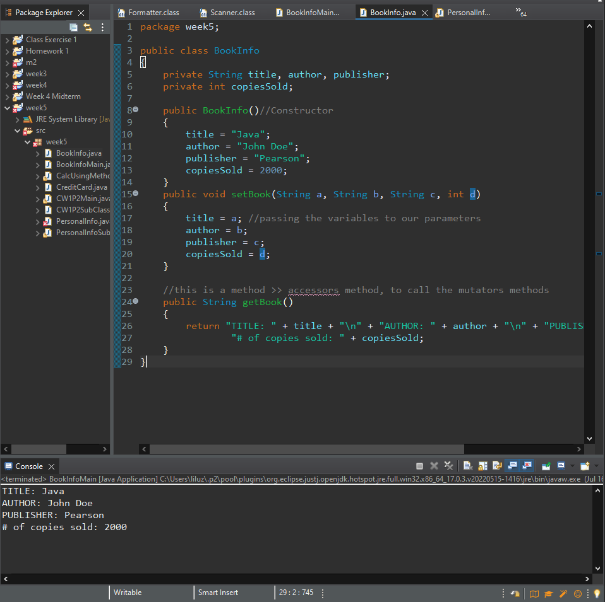

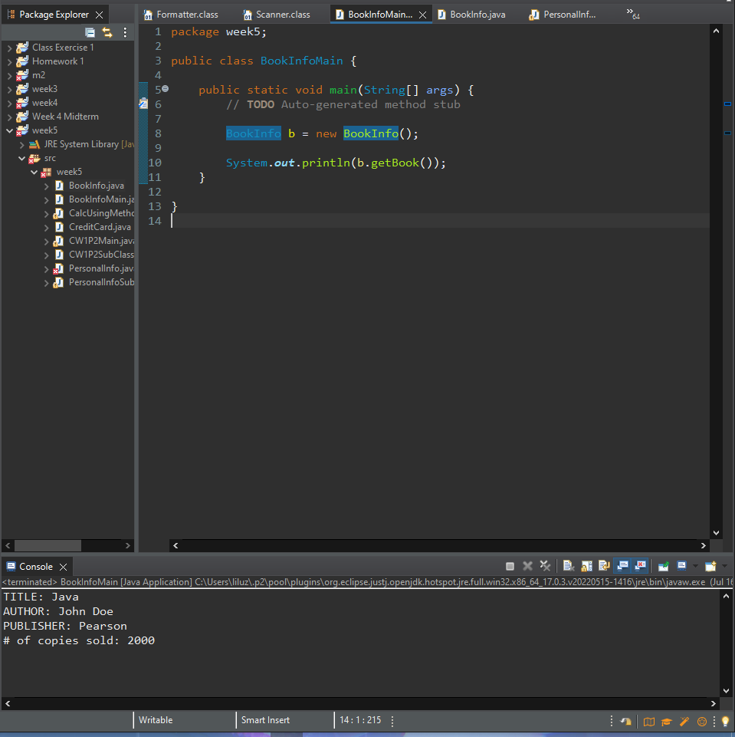

**Challenge Exercise:** Complete the following below, make sure to have an output.

**#5 print screen the output below with code below here**

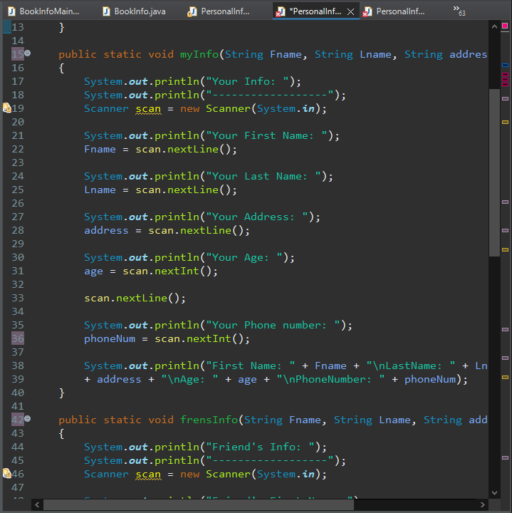

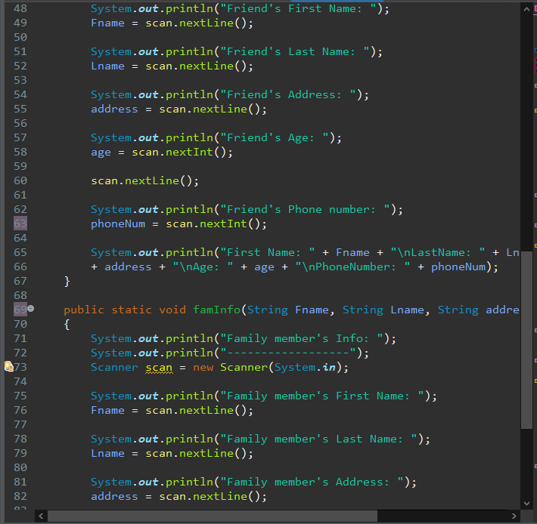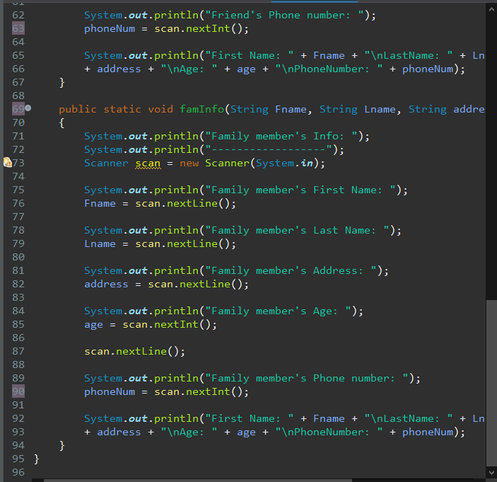 **Submit this document to Module 5 Class Exercise.**